PUMA ESS CAT BB CAP
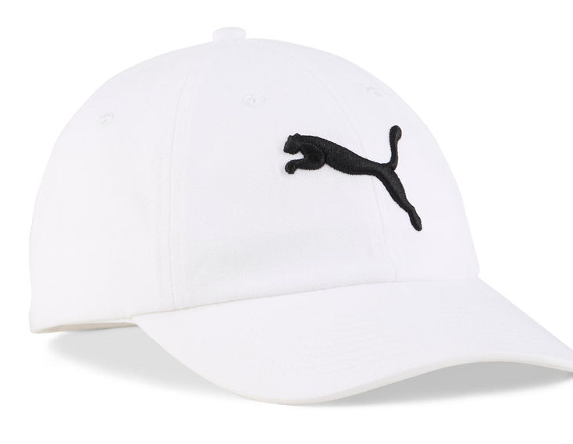
PRICE: Approximately Rs. 3,499

_{Introduction:}
The PUMA ESS CAT BB Cap is a classic and versatile headwear accessory designed for everyday comfort and timeless style. Featuring a simple yet iconic design, this cap is perfect for casual wear, outdoor activities, and sports-inspired outfits. Its lightweight construction and breathable fabric ensure all-day comfort, while the adjustable back closure provides a secure and personalized fit. Whether you’re heading out for a walk, running errands, or completing a sporty look, the PUMA ESS CAT BB Cap adds effortless style with trusted Puma quality.

Product Overview:
The PUMA ESS CAT BB Cap features a traditional baseball cap silhouette with a curved visor for sun protection. Designed for daily use, it offers comfort, breathability, and easy adjustability, making it suitable for various head sizes and activities.
About the Brand:

Puma is a globally recognized sports and lifestyle brand known for combining performance, innovation, and modern design. Puma footwear is trusted worldwide for its comfort, durability, suitable for both athletic and casual wear.

Key Features:
- Spacious main compartment for daily essentials
- Classic baseball cap design
- Curved brim for sun protection
- Adjustable back closure for a custom fit
- Lightweight and breathable fabric
- Iconic PUMA Cat logo on the front

Design & Build Quality:
The PUMA ESS CAT BB Cap features a clean and structured design with reinforced stitching for durability. Its curved visor maintains shape over time, while the soft fabric ensures comfort during extended wear, while the padded back panel enhances comfort during extended use.

Storage & Capacity:
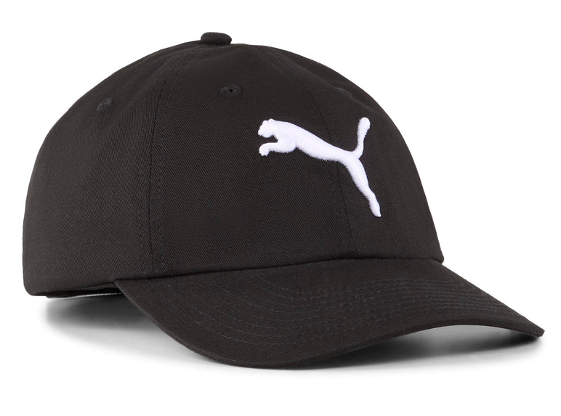
The cap is lightweight and easy to store, fitting conveniently into backpacks, gym bags, or travel luggage. Its flexible structure allows it to be carried without taking up much space.

Material & Durability:
Made from high-quality cotton or cotton-blend fabric, the PUMA ESS CAT BB Cap is designed for everyday use. The material offers breathability and durability, ensuring long-lasting comfort and resistance to wear.
Ideal For:
- Everyday casual wear
- Outdoor activities and travel
- Sports-inspired outfits
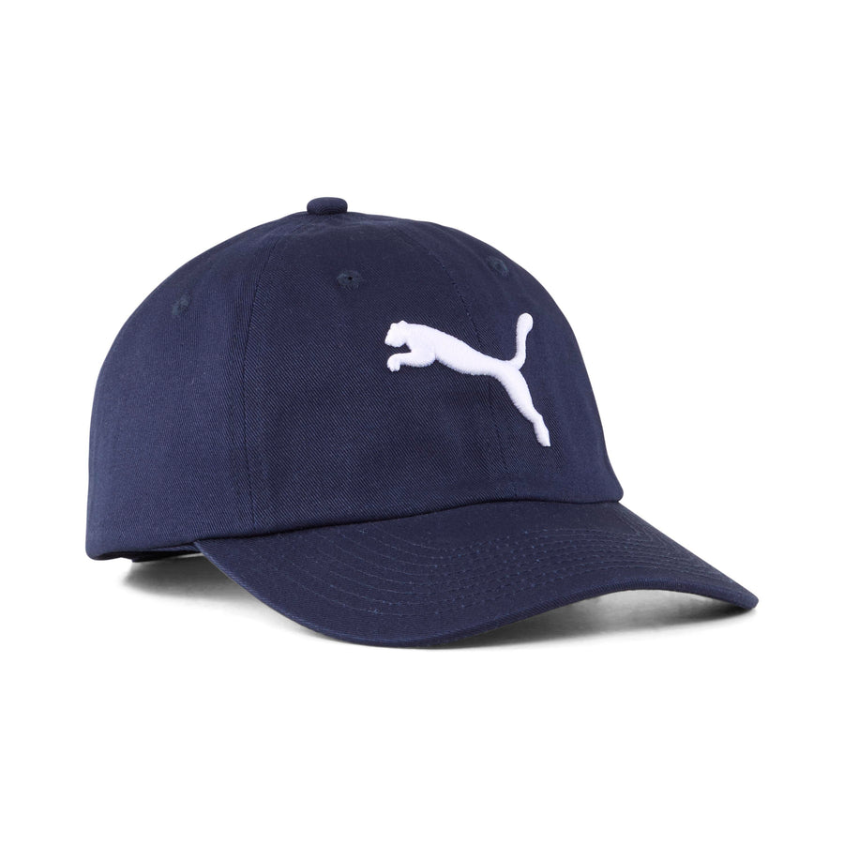
- Sun protection during daily routines

Care Instructions:
- Hand wash gently with mild detergent
- Do not bleach or machine wash
- Air dry to maintain shape
- Avoid excessive folding

Product Specifications:
- Brand: Puma
- Model: ESS Cat BB Cap
- Product Type: Baseball Cap
- Material: Cotton or cotton blend
- Closure: Adjustable back strap
- Fit Type: One size fits most
- Visor: Curved brim
Product Summary:
The PUMA ESS CAT BB Cap is a timeless accessory that combines comfort, simplicity, and iconic branding. Ideal for daily wear and casual styling, it offers a reliable fit, breathable comfort, and classic Puma appeal.

